

**Micro-Hydroelectric Power Generation Plant**

**PROPOSED GENERATION**

**OF ELECTRIC POWER IN RIVER NDARUGO, NJORO.**

***PROJECT TEAM***

*Dominic Kata, Egerton University*

*Gift Masaka, Egerton University*

*Esther Njeri, Egerton University*

*Midi Enock, Egerton University*

*Peter Macharia, Egerton University*

*Faith Mutitu, Egerton University*

*Sylvia Chirchir, Egerton University*

*Stacey Jara, Egerton University*

*Mumina Hasso, Egerton University*

*Emmanuel Kiplimo, Egerton University*

*Elsie Wandera, Egerton University*

*Bilton Kamau, Egerton University*

*Kelvin Muyundo, Egerton University*

*Paul Kinoti, Meru University*

*Marcelline Akoth, Egerton University*

*Peter Kabaria, Egerton University*

*Daniel Nasoro, Egerton University*

*Athman Mohammed Shee Ali, Egerton University*

*Erik Mokayae, Moi University*

*Brian Mungai, Egerton University*

*Mohammed Omar, Egerton University*

*Davis Sirali Ngesa, Egerton University*

*John Gicheru, Masinde Muliro University of Science and Technology*

*Ebby Jebet, Egerton University*

*Yego Stanley, Egerton University*

*Pauline Nyokabi, Egerton University*

*Onesmus Muema Mulwa, Meru National Polytechnic*

*Eunice Kerubo, Egerton University*

*Samuel Mbugua, Egerton University*

*Ernest Kipngetich, Technical University of Kenya*

*Calvin Kapwepwe, Dedan Kimathi University of Technology*

*Bill Ojando Andalia, Technical University of Kenya*

*Daisy Nduta, Egerton University*

*Obadia Kieti, Jomo Kenyatta University of Agriculture and Technology*

*Stephen Okwiri, Technical University of Kenya*

*Elly Obare, Kenyatta University*

*Fred Mbau, Egerton University*

*Esther Wavinya, University of Nairobi*

*Joseph Mituki, Egerton University*

*Nicholas Tum, Egerton University*

*Austin Steve, Technical University of Kenya*

*Martin Chege, Dedan Kimathi University of Technology*

*Mary Muthoni, Egerton University*

*Simon Nayweni Ogubi, Multimedia University*

*Gladys Nduta, Egerton University*

*Dennis Murimi, Egerton University*

*Solomon Ndichu, Kenyatta University*

*Pius Rotich, Egerton University*

*Elizabeth Achieng, Egerton University*

*Alfred Mutua, Egerton University*

*Stephen Kaguri, Dedan Kimathi University of Technology*

*Gladys Manyola, Egerton University*

*Victor Chaba, Egerton University*

*Salim Khalifani, Egerton University*

*Kelvin Maina, Egerton University*

*Jimmy Mwange, Egerton University*

*Beth Nyambura, Taita Taveta University*

*Mercy Chepngetich, Egerton University*

*Amos Ruto, Egerton University*

*Jamal Omwanda, Egerton University*

*Brian O’Brien, Egerton University*

*Glory Kinya, Egerton University*

*Cerrullo Kamau, Kitale National Polytechnic*

*Agnes Benita, Egerton University*

*Samuel Kiragu, Egerton University*

*David Muruka, Egerton University*

***CONSULTANTS***

*Eng. John Mwiti, Geothermal Development Company*

*Eng. Dr. F. Manene Muriuki, Lecturer, Electrical and Control Engineering, Egerton University*

*Eng. Kobia Mucheke, Technologist, Electrical and Control Engineering, Egerton University*

*Eng. Henry Wambua, KOKO Networks*

*Sarafina Nawiti, Zambia*

*J. Gatune, Fridah Munene, Maastricht School of Management*

*Dennis Kiogora, Energy Policy & Engineering, Energy Project Development Advisor from Nuclear Power & Energy Agency*

*Germano Mugambi, Electrical and Control Engineering Department*

*Jedida Mwangi,**Senior Electrical & Control Engineer, Hyoung.*

## ABSTRACT

Njoro is an Agricultural town 18km south west of Nakuru. It is situated on the western rim of the rift valley and known for its abundant rainfall—an attribute that contributes to hydroelectric potential. More than 800 million cubic feet of rainwater fall on the county annually. Approximately half ends up in the County’s storm water collection system where it flows beneath streets and is discarded into nearby rivers and creeks. As the water loses elevation, dropping by as much as 300 feet, its potential energy goes to waste. If this energy could be converted to electricity, it could conceivably supply dozens of public facilities and homes with clean, renewable energy.

A study was carried out to examine as to whether rainwater collected by Nakuru County’s storm water collection system is a viable resource for small-scale power generation. It explored methods of retrofitting the existing storm water collection system with micro-hydroelectric turbines, and it evaluates the costs and benefits of such modifications. The proposed project is intended to serve as a design basis for communities contemplating storm water as an energy resource.

To implement the proposed project, two sites were chosen for detailed analysis. One site is located in Egerton University, where rainfall collected from the adjacent neighborhood can be dropped more than 120 feet down to river Ndarugu. The other site is located near Mogotion primary school. While the technology to build practical, micro-hydroelectric systems is well proven and widely available, adapting this technology to interface with an existing storm water system in an urban environment was found to involves considerable challenges.

The most significant challenge is the irregularity of the storm water resource. On average, Nakuru County experiences 175 days of measurable precipitation each year. Precipitation can vary from as little as zero to as much as ten inches in a day. The irregular nature of the resource results in intermittent energy production and a low plant capacity factor. A low capacity factor implies that the cost of the system will be high in relation to the amount of energy produced. It is difficult to arrive at a favorable capacity factor if there is no water available several months out of the year. This is an inherent problem with building a hydro scheme around a storm water system.

Another challenge is the cost of interfacing with the existing storm water system. If pipes must be routed beneath river basin, the added expense can be prohibitive. It is almost impossible for a small generation system to recoup such a large capital outlay. For one of these systems to have a reasonable chance at economic success, storm system revisions either must be avoided entirely, or accomplished as part of separately funded storm system upgrades or repairs.

Irrespective of storm system revisions, both study sites were found to cost less to build and operate than they return over the course of their 20-year lives. The levelized cost of energy from the facilities is significantly more than cost of energy from the local utility. From a purely economic perspective, storm water-based hydroelectric energy is economically viable in both Egerton University and the immediate communities at today’s energy prices.

If, however, the primary motivation is to showcase sustainable technology and provide a springboard for public dialogue, then a demonstration system in a visible location may be well worth the expense. The cost of the system would not be recovered directly in the form of kilowatt-hours produced, but if it influences the behavior of people in the community and inspires conservation efforts, then its value may prove to be incalculable.

## Acknowledgements

We would like to express our sincere gratitude to Prof. A. Kahi, Deputy Vice –Chancellor, Egerton University for his efforts and help in developing this proposal.

Secondly like to recognize Eng. Michael ketel Sembele for is inspirational and mechanical technical skill and advice.

Thirdly wish to recognize Eng. Dr. Manene Muriuki and Egerton University Technology Enthusiasts Engineers Club for the financial support and mobilization towards success of this project.

Lastly recognize John Mwiti, Mr. Kobia Mucheke and M-HEP team members for initiation this project and community participation work.

## List of Acronyms

Acronym Definition

AC Alternating current

DC Direct current

CFS Cubic feet per second

FDC Flow Duration Curve

GIS Geographic Information System

GPM Gallons per minute

IRR Internal Rate of Return

kWh Kilowatt-Hour

Mhep Micro-Hydroelectric power

MPP Maximum power point

NEC National Electrical Code

NPV Net Present Value

PAT Pump as Turbine

PLC Programmable Logic Controller

PVC Polyvinyl chloride

STP Standard Temperature and Pressure

Table of Contents

ABSTRACT i

Acknowledgements ii

List of Acronyms iii

1.0 Introduction 1

1.1 Background 2

1.2 Study Approach 3

1.3 Scope 4

1.4 Justification 4

1.5 Objectives 5

1.5.1 Main Objective 5

1.5.2 Specific Objectives 5

2.0 Micro-Hydro Technical Review 6

2.1 Introduction 6

2.1.1 Head and Flow 6

2.1.2 Pipe Losses 7

2.1.3 Turbulent Flow and the Moody Diagram: 8

2.1.4 Equipment Efficiencies 8

2.1.5 Flow Estimation Methodology 9

2.2 Head Measurement Methodology 9

2.3 System Components 10

2.3.1 Intake 10

2.3.2 Penstock 10

2.3.3 Turbine 11

2.3.4 Pelton turbine. 11

2.3.5 Pumps as turbines (pats). 12

2.3.6 Turgo turbine. 12

2.3.7 Power Conditioning 12

2.3.8 Powerhouse 13

2.4 Chapter Summary 13

3.0 Site Assessment 14

3.1 Overview 14

3.2 Climate 14

3.2.1 Precipitation Exceedance Chart 14

3.3 General Topography 15

3.3.1 Drainage Basins 16

3.3.2 Runoff Percentages 16

3.3.3 Site Selection Criteria 17

3.3.3 Access to Water 17

3.3.4 Height of Drop 18

3.3.5 Catchment Area Size 18

3.3.6 Proximity to Low Voltage Utility Lines 18

3.3.7 Ecological Impacts 18

3.3.8 Property Status 18

3.3.9 Study Sites 18

3.4 Summary 19

4.0 Conclusions and Recommendations 20

4.1 Development Plan & Schedule 20

4.2 Budget proposal for feasibility study 20

References 21

# 1.0 Introduction

Energy demands are increasing worldwide. Rising fuel costs and concerns over atmospheric pollution have spurred interest in energy from renewable sources. Many forward-thinking communities are taking a closer look at their renewable natural resources to determine which, if any, are suitable for development. Thanks to a variety of technological advancements, energy sources that were once discounted impractical are now finding their way into the mainstream.

Anyone who has spent time in Egerton University, Njoro will recognize that the campus school is blessed with river Ndarugu which is situated along the lower border toward Ahero, Njokerio and campus gate. The river has several rapids and cataracts along its course that are ideal for a MHEP generation. More recently, the question has been raised as to whether electricity can be generated on a much smaller scale to power the school lighting systems and reduce electricity bills, and with fewer environmental impacts, by exploiting rainwater that flows through the forest streams and water. Such a scheme would utilize small and inexpensive micro-hydroelectric turbines, which have become increasingly available in recent years.

Currently, the energy potential Ndarugu River goes unutilized as runoff and is discarded into nearby rivers and creeks.

This proposal assesses the hydroelectric potential of surface water in Ndarugu. It explores methods of retrofitting the existing surface water collection system with micro-hydroelectric turbines, and it evaluates the costs and benefits of such modifications. The proposed Micro- Hydroelectric power generation plant is intended to serve as a design basis for communities contemplating the development of this renewable resource.

In an effort to make the project as practical as possible, three sites were chosen for detailed analysis. From the evaluation of these sites, conclusions were drawn about other potential sites within the county and about the viability of surface water-based systems in general. While the technology to build practical, micro-hydroelectric systems is well proven and widely available, adapting this technology to interface with an existing surface water system in an urban environment was found to involves considerable challenges.

We The proposed Micro- Hydroelectric power generation plant, do not recommend the wide scale deployment of surface water-based hydro systems at this time. However, a model may be worthwhile as a means of showcasing sustainable technology and increasing public awareness of energy issues. This demonstration project will also serve as a platform for the research and development efforts of communities in need of such system. If energy prices continue to rise and technological advancements result in simpler and cheaper micro hydro equipment, the economics of these systems may substantially improve. It is expected that this project will inspire the kind of out-of-the-box thinking that will be necessary to solve the world’s energy problems.

## 1.1 Background

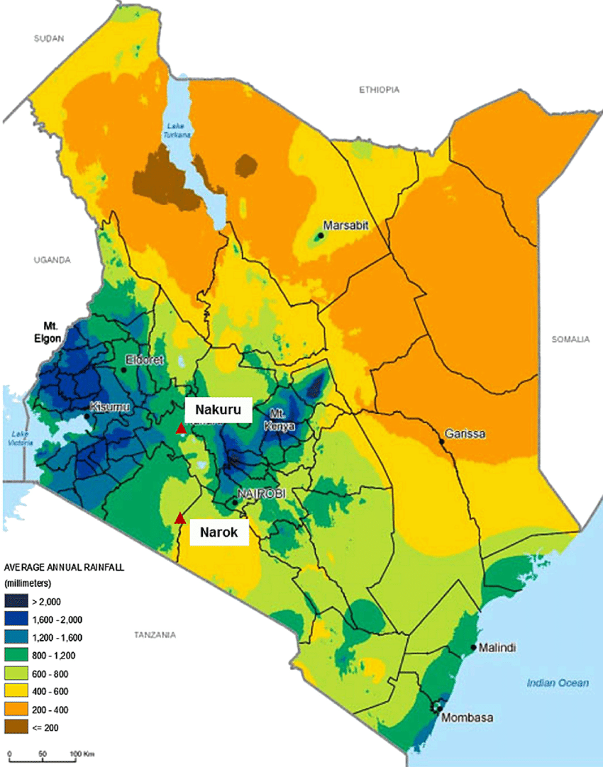This Micro- Hydroelectric power generation plant design and development represents a joint effort between Egerton University, Maastricht (IAP Flyer DEF), Geothermal Development Company, Kenya Industry and Entrepreneurship Project by the Ministry of Industry, Trade and Cooperatives (MoITC), with support from the World Bank Group over the next six years between 2019-2024(KIEP Factsheet) and the county under the umbrella of its Community Conservation Program. The Program helps landowners in the private, public, and non-profit sectors carry out the vision, mission, and values of the county. One way it does this is by sponsoring credible investigations that can lead to the installation of renewable energy systems that benefit local communities. With a matching research and development grant from African Development Bank and a group of international financial investors (Business Daily, Thursday, January 11, page 7) the partners launched this feasibility study in January 2018.Technical assistance was provided by scientists from GDC,

## 1.2 Study Approach

Some experts contend that a hydrology study for a micro-hydro project should be based on no less than 15 years’ worth of daily records (Harvey, 2006). Obviously, few people have the time or the inclination to collect that much data themselves. It is common practice, therefore, to correlate a stream’s flow to a resource for which historical data already exists.

For this study, that resource is rainfall. Because the storm water system is fed almost exclusively by precipitation, and because the collection areas are defined, this study lends itself well to the area-rainfall method of analysis. Daily precipitation data collected over the last ten years is readily available for Egerton University, as it also has its own meteorological department and a weather station within the school.

Our approach is to evaluate three specific sites, though very different, study sites. From our evaluations, conclusions are drawn about other potential sites within the county and about the viability of storm water-based on micro hydro in general. Through these efforts, we seek to answer four basic questions:

1) How much energy is there dropping down the bluffs of Nakuru County in the form of runoff?

2) How much of this energy can be harnessed for electrical generation?

3) What is the preferred method of harnessing this power?

4) Is it practical and cost-effective to develop this resource?

The first question is strictly theoretical. It serves to quantify the energy of the resource without regard for how it might be captured. Is there a lot of energy present or only a little?

The answer places a magnitude on the resource so that we can estimate the benefits of developing this source of energy.

The second question considers the constraints and limitations of practical systems. Of the total available energy, only a fraction can be captured for use. How much is this amount?

The third question explores solutions based on available technology. Although the field of micro-hydro is continually evolving, with new products being developed all the time, every effort has been made to include only solutions that are proven or have a high probability of success.

The fourth question attempts to place the proposal within a framework that decision makers can use to evaluate its viability. An economic analysis is central to this process, but should not be the sole basis for a decision. Less quantifiable factors—such as personal values, community involvement and education—should also be considered.

## 1.3 Scope

This project focuses on identifying and evaluating areas within Nakuru County that have both high topographic relief and large catchment areas that may be promising for hydroelectric development. We do not attempt an exhaustive analysis of Nakuru County’s entire storm water system, nor do we address potential sites that may exist outside of the county. The study is structured to assist decision makers in determining whether rainwater is a viable resource for small-scale, distributed power generation. The engineering solutions provided herein are based on the best-available information and were derived solely for the purpose of assessing feasibility. More precise data collection and analysis should follow the decision to develop any specific site.

## 1.4 Justification

More than 800 million cubic feet of rainwater fall on Nakuru surface area every yearly. Approximately half of this water ends up in the County’s storm water collection system where it flows beneath county streets to nearby rivers and creeks. As the water loses elevation, 3 x 1012 joules of potential energy go to waste. How much energy is this? Based on statistics from the Energy Information, it is enough to meet the electrical needs of 78 typical Nakuru homes, course; it is not realistic to assume that all of this energy could ever be captured. The entire storm water system would have to be re-engineered for that singular purpose, and even then, a substantial amount of energy would be lost to the inefficiencies of the conversion process. Nevertheless, the idea of retrofitting the storm water system with grid-tied micro-hydroelectric turbines is worthy of investigation. The concept may find application in county throughout and that have the right combination of climate, topography, hydrology and infrastructure.

Our country needs sustainable and environmentally benign sources of electric power. Small, community-sponsored projects are an important step toward achieving that end. At one level, they can ease the burden on the energy infrastructure by producing Electricity near the point of use. At another level, they can increase public awareness and act as catalysts for change. When people see micro-hydro plants in operation, producing clean, renewable energy, they become more likely to invest in similar technologies for themselves. Such awareness is necessary if our society is going to end its dependence on fossil fuels and create a brighter, more sustainable future.

With the onset of COVID-19 Pandemic, there is a new norm to work from home. With implementation of the proposed Micro-Hydroelectric power, lower costs of energy are expected , we can encourage urban to rural shifts so that work becomes more efficient and decongestion in cities can be minimized.

Engineering students as well as other courses need hands-on skills to suit them to the evolving world and expose them to networks. This project will be used to train students on power systems, social skills and other engineering skills. This will save costs of otherwise having to conduct field trips and sharpen them for solving real world problems.

## 1.5 Objectives

1.5.1 Main Objective

To design, develop and install a Micro hydroelectric power generating system plant.

* + 1. Specific Objectives

1. To establish an appropriate site and make preliminary designs.
2. To design a Micro- hydroelectric plant.
3. To develop, test and optimize the hydroelectric plants.
4. To install, test and commission the best hydropower plant on site.

# 2.0 Micro-Hydro Technical Review

## 2.1 Introduction

Typically thinking of hydroelectric, it is seen as large, capital-intensive projects involving dams, reservoirs and cubic miles of retained water. Rarely is it thought of the thousands of small-scale systems throughout the world that do not use dams at all. These tiny generating plants are classified as micro-hydro if they generate less than 100 kW of power (Harvey, 2006). Yet, whether a hydro plant is large or small, the principles behind its operation are the same. This chapter explains the theory and technology on which this study is based. It begins by explaining how head and flow measurements are used to calculate power. It then addresses the losses and inefficiencies caused by piping and machinery. Finally, it describes the essential components of a micro-hydroelectric a system.

### 2.1.1 Head and Flow

Whenever water flows from a higher elevation to a lower elevation there is the potential to harness that energy to do useful work. The energy available in the water is a function of two variables: the head and the flow-rate. The head is the vertical distance through which the water can be made to fall. It is typically measured in units of feet. The flow-rate is the quantity of water moving past a fixed point in a given time and is measured in cubic feet per second (CFS) or gallons per minute (GPM). Both head and flow-rate contribute equally to the energy of a stream. The greater the volume of water and the higher up it is, the more energy it contains. A small stream with a large vertical drop can supply the same amount of energy as a much larger stream with a very slight drop. It is the interaction of head and flow-rate that determines power. For this reason, river Ndarugu, with its impressive vertical drops can potentially generate useful amounts of power using relatively small volumes of water. The relationship can be expresses as follows:

P = Q×H ×r × g max (2.1)

Where

Pmax = power

Q = volumetric flow-rate

H = gross head

r = density of water

g = gravitational constant

When assessing a micro-hydro site, one is interested in quantifying both the available head and the flow-rate, since both are necessary in determining power. Of the two attributes head is usually considered more desirable because it results in smaller diameter pipes and Hydro-electric fittings, reducing overall system costs. However, when working with a resource as site-specific as hydropower, one must accept whatever is available.

### 2.1.2 Pipe Losses

The head in equation 2.1 is the gross head, which does not account for losses due to turbulence and friction in the piping. The effective head, which is the head manifest at the turbine inlet in the form of hydraulic pressure, is the gross head minus the head loss. Head losses are a function of the pipe length, diameter, surface texture, flow-rate, and the number and type of fittings between the intake and the turbine. Typically pipe losses are broken out into two parts: the losses due to the pipe itself and the losses due to the fittings.

For a straight pipe, friction is proportional to the velocity of the water and to the ratio of the pipe’s length with respect to its diameter. This relationship is expressed mathematically by the Darcy Equation:

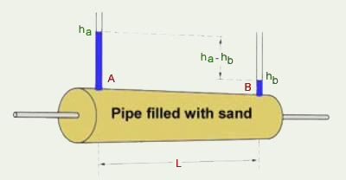 he equation for Darcy’s Law is based on the observations that the flow rate through a porous medium (such as an aquifer) is proportional to the cross-sectional area perpendicular to flow and is also proportional to the head loss per unit length in the direction of flow. Putting these two proportionalities together gives the following equation:

Q = KA (hL/L), where Darcy’s Law Apparatus

Q = flow rate of liquid through the porous medium, typically in ft3/sec,

A = cross-sectional area perpendicular to flow, typically in ft2,

hL = head loss over a horizontal length, L, in the direction of flow (hL in ft and L in ft)

The diagram at the right shows an experimental apparatus illustrating the Darcy's Law equation and its parameters.

Darcy's Law is valid only for laminar flow, which occurs for Reynold's number less than 1. Reynold's number (Re) for flow through a porous medium is defined as: Re = ρVL/μ, where ρ and μ are the density and viscosity of the liquid, V is the flow velocity (Q/A), and L is a characteristic length, typically taken as the mean grain diameter of the medium. Most practical applications of groundwater flow have Re < 1, and thus can be modeled with Darcy's Law.

The friction factor is specific to the material and construction of the pipe (i.e. whether its surface is rough or smooth) and the characteristics of the flow (whether it is laminar or turbulent). The most widely used method of obtaining the friction factor is through the use of the Moody diagram. The Moody diagram shows the friction factor plotted against the Reynolds number, with a series of parametric curves related to the relative roughness of the pipe.

### 2.1.3 Turbulent Flow and the Moody Diagram:

*Turbulent flow* is a flow regime in which the movement of the fluid particles is chaotic, eddying, and unsteady. Turbulent flow occurs at Re > 4000.  Due to the complex nature of turbulent flows, scientists and engineers use empirical rather than theoretical approaches to model and design processes and machinery involving fluids.

As an initial approach to ‘empirical approximations’ to fluid flow in conduits, we shall utilize the dimensional analysis approach described in previous lectures.  It was earlier found that for an incompressible fluid flow in a straight, horizontal, circular pipe of constant cross-sectional area, the significant variables are: that the wall shear stress ***τw,*** the distance from the inlet (*x*), pipe diameter (*D*), flow average velocity (*um*), fluid density (*ρ*), fluid viscosity (*μ*), and the wall roughness (*ε*).  Dimensional analysis resulted with the following relationship:

http://faculty.kfupm.edu.sa/CHE/alshami/teaching/Che%20204/Lecture%20Notes/Chapter%203_Lect%20Notes_Turbulent%20Flow%20and%20Moody%20Diagram_files/image002.gif

The functionhttp://faculty.kfupm.edu.sa/CHE/alshami/teaching/Che%20204/Lecture%20Notes/Chapter%203_Lect%20Notes_Turbulent%20Flow%20and%20Moody%20Diagram_files/image004.gif, which varies with the relative roughness http://faculty.kfupm.edu.sa/CHE/alshami/teaching/Che%20204/Lecture%20Notes/Chapter%203_Lect%20Notes_Turbulent%20Flow%20and%20Moody%20Diagram_files/image006.gif and Reynolds number is designated *f*, the friction factor.

Expressing the above relationship in terms of *f,* we have:

http://faculty.kfupm.edu.sa/CHE/alshami/teaching/Che%20204/Lecture%20Notes/Chapter%203_Lect%20Notes_Turbulent%20Flow%20and%20Moody%20Diagram_files/image008.gif

Other versions in more common use are the *Fanning* friction factor:

http://faculty.kfupm.edu.sa/CHE/alshami/teaching/Che%20204/Lecture%20Notes/Chapter%203_Lect%20Notes_Turbulent%20Flow%20and%20Moody%20Diagram_files/image010.gif

One should always attempt to minimize the length of the pipe as well as the number of elbows, valves and other fittings in the flow path, as their combined losses can be significant. Any reduction in the effective head will reduce the power output proportionately. It is not uncommon for a micro-hydro system to have an effective head that is as much as 30 percent less than the gross head (McKinney, et al., 1986).

### 2.1.4 Equipment Efficiencies

Pipe losses are not the only losses that must be considered. The efficiencies of the turbine, generator and electronics also rob power from the system. Small water turbines rarely achieve efficiencies greater than 80% (Schumacher, 2004). Combined with losses in the generator and power electronics, the overall efficiency is likely to be closer to 50 percent (Masters, 2004). To account for these equipment losses, the power equation is modified by an efficiency factor (h). Hence:

P = Q× H × g ×r ×h effective (2.5)

This equation provides a reasonable estimate of the power output of a hydroelectric system regardless of its size or construction. The relationship in this form will be used throughout this analysis.

### 2.1.5 Flow Estimation Methodology

The flow-rate can either be estimated using analytical techniques, such as the area-rainfall method, or measured directly. In either case, a hydrology study should be based on many years of daily records (Harvey, 2006). Typically, for short duration studies like this one, the area-rainfall method is preferable because historic precipitation data is relatively easy to obtain. It is always a good idea, however, to take periodic site measurements, if possible, to verify that the results of the analysis are reasonable.

In this study, flow-rates were estimated as follows:

• Step 1. 30-years’ worth of daily rainfall data for Nakuru County was obtained from the Regional Climate Center.

• Step 2. A rainfall-duration curve was constructed. This curve statistically relates rainfall quantities to the number of days of occurrence.

• Step 3. Catchment areas were calculated from drainage basin maps obtained from Nakuru County Works.

Topographical maps acquired from the Geographic Information System (GIS) department were used to locate potential hydro sites.

• Step 4. Runoff quantities were calculated using the area-rainfall method. Impervious surface factors were obtained from Nakuru County Works.

• Step 5. Site-specific flow-duration curves were constructed. These curves were used to identify the flow-rates with the greatest energy content and to calculate the power potentials of the sites.

## 2.2 Head Measurement Methodology

One can determine the gross head by surveying the land using GIS equipment or by counting the contours from a good-quality topographical map. Either method is considered adequate for site assessment calculations (Penche, 1998). The method used in this study was to count the contours on a topographical map with 10-foot intervals. The resolution of the map was sufficient to obtain head measurements accurate to within a few feet. For a detailed design, which would follow a decision to build a system, an accuracy of at least 3% is required (Harvey, 2006).

## 2.3 System Components

The simplest micro-hydro systems are run-of-the-river, meaning they do not store up water behind dams. Instead, a portion of the stream’s flow is diverted into a pipe—called a penstock—that parallels the watercourse for some distance to a point downstream where the diverted water rejoins the main flow. The penstock delivers water to the turbine, which turns a shaft coupled to a generator. Various electrical devices regulate and condition the electrical power for storage or use. Because of the high cost and complexity of systems that store water, only run of the river systems have been considered in this study. Figure 2.1 illustrates how an Hydroelectric power plant works.

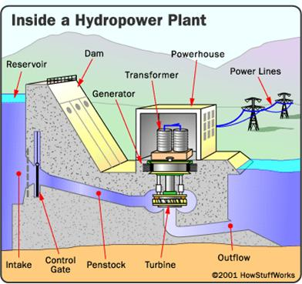

Figure2.1 Wworking of HEP

### 2.3.1 Intake

The purpose of the intake is to direct a steady, air-free stream of water into the penstock. A properly designed intake should prevent gravel and floating debris from entering the pipe.

A good intake is self-cleaning and resists being clogged by dirt, leaves and other debris.

Often, not enough attention is paid to this component, resulting in a poorly functioning system that requires frequent maintenance (Harvey, 2006).

### 2.3.2 Penstock

Most hydro schemes use a penstock to deliver to water under pressure to the turbine. The distance that the water drops as it travels through the penstock is what generates the head.

The length of the penstock has no bearing on the gross head, but it does influence the effective head because of fluid friction. The penstock should be of sufficiently large diameter to supply the needed flow without excessive losses. For any given diameter of pipe, there is an optimum flow-rate, above which the power will begin to decrease with increasing flow. Therefore, care must be given to selecting the proper size pipe for a given application. While it is true that increasing the size of the pipe will always result is smaller losses, it may not be economical to do so.

Large diameter pipes are expensive, and in many systems, the penstock is the single most expensive component. Although there are a variety of pipe materials available, most small-scale systems use either polyethylene or PVC because they are relatively inexpensive and easy to work with.

### Designing a penstock entails more than just selecting the right size and material for the pipe. PVC pipe expands and contracts approximately five times as much as steel (Charlotte,2006). Allowance must be made for the expansion and contraction that occurs as a result of temperature. In addition, a phenomenon commonly known as “water hammer” must be considered in the design or the surge pressures that develop from the rapid closing of valves can rupture the pipe. These and other concerns must be carefully considered during the design process.2.3.3 Turbine

The turbine converts the kinetic energy of the water into torque. There are several kinds of micro-hydro turbines available, each suited to a particular head and flow. Turbines can be broadly categorized as either impulse turbines or reaction turbines. Impulse turbines convert the kinetic energy of a jet of water in air into movement by striking buckets or blades. By comparison, the blades of a reaction turbine are totally immersed in the flow of water, and the angular as well as linear momentum of water is converted into shaft power.

Reaction turbines typically require large flows and moderate heads, though one must be careful with such generalizations, as there is much overlap between the different designs. Variety of turbine-generator assemblies is commercially available, but there is no guarantee of finding exactly the right one for a particular site. Common types of impulse and reaction turbines are presented below.

### 2.3.4 Pelton turbine.

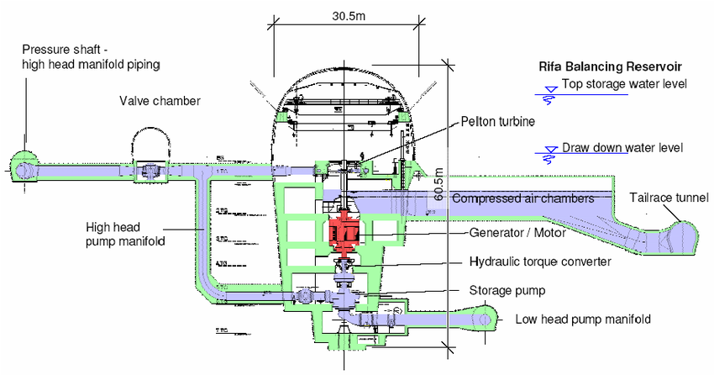The Pelton turbine consists of a set of specially shaped buckets mounted on a circular disc. The disc is turned by jets of water, which are discharged from one or more nozzles arranged around the disc’s circumference (Figure 2.2). The buckets are designed to deflect the jet through 165 degrees, which is the maximum angle possible without the return jet interfering with the following bucket for the oncoming jet (Harvey2006). In large scale hydro schemes Pelton turbines are normally only considered for heads above 150m, but for micro-hydro applications Pelton turbines can be used effectively at heads down to about 20m (Eisenring, 1991). Pelton turbines are not used at lower heads because their rotational speed becomes very slow and the runner required is very large and unwieldy. These turbines have efficiencies typically in the range of 70-90% (Masters, 2004).

Figure 2.2. Pelton Turbine Cross-Section (Warwick, 1984)

### 2.3.5 Pumps as turbines (pats).

When the flow in a-centrifugal pump is reversed, the pump becomes a hydraulic turbine. Pumps are widely available, and in some applications may offer significant advantages in terms of cost and simplify over specialized hydraulic turbines. To achieve efficient operation of a pump as a turbine, the operating head and flow-rate must be increased over the rated head and flow-rate. Because pump catalog performance curves describe pump duty, not turbine duty, choosing the right pump for a particular site requires the use of correction factors, which are not always easy to obtain (McKinney, et al., 1986). Some pump manufactures have collected this data and can help with the selection process. Unlike the other types of turbines mentioned, the flow-rate to a PAT is fixed for a given head. PATs offer the greatest advantage, in terms of cost and simple, for sites where the alternative would either be a cross flow turbine operating at low flow, or a multi-jet Pelton (Williams, 2006).

### 2.3.6 Turgo turbine.

The Turgo turbine is similar to a Pelton turbine except that the jets not in the same plane as the wheel, i.e. the water strikes the buckets and passes through the wheel (Figure 2.2). Unlike the Pelton, the flow-rate is not limited by the discharged water interfering with the incoming jet. As a consequence, a Turgo turbine can have a smaller diameter runner than a Pelton for equivalent power (Boyle, 2004). An additional advantage is that for the same head and runner diameter, the speed is about twice that of the Pelton. The Turgo is efficient over a wide range of speeds and shares the general characteristics of a Pelton turbine including the fact that it can be mounted either horizontally or vertically. A Turgo runner is more difficult to make than a Pelton and the vanes of the runner are more fragile than Pelton buckets. They require about the same heads as do Pelton’s and they sometimes employ multiple jets to allow part flow operation.

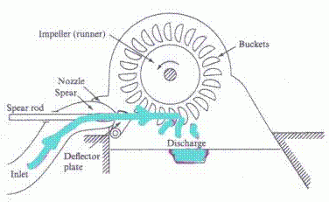

Figure 2.3. Turgo Turbine (British Hydropower Association, 2005)

### 2.3.7 Power Conditioning

Recent advances in the field of power electronics have made small-scale power generation more practical and affordable than ever. Traditionally, the synchronous speed of the generator had to be precisely regulated in order to produce electricity the right frequency and voltage for most applications. This often meant employing complicated mechanical governors (McKinney, et al., 1986). Today, much of this regulation is done electronically.

Affordable, off-the-shelf devices (some developed by the wind or photovoltaic industries) maximize system performance and produce electric in a form that is ready to use. Power electronic devices commonly used in small-scale systems are rectifiers, inverters, load controllers and generator protective relays.

### 2.3.8 Powerhouse

The powerhouse is the structure that protects the turbine and the generator from the elements. As a side benefit, it provides a certain amount of sound insulation. Typically, the powerhouse is located on the edge of the watercourse with the tail water discharging out the bottom. It can be as simple as a weatherproof box set over the equipment it houses, or it can be an entire outbuilding, large enough for people to work inside.

## 2.4 Chapter Summary

The physical principles governing hydropower apply to all hydroelectric systems, regardless of scale. The power of a system is a function of its head and flow-rate. Equipment efficiencies reduce the power output of a site, as does the friction of water passing through pipes and fittings. There are several types of turbines available—each suited to a specific range of heads and flow-rates. One’s choice of turbines is highly depended on the sites characteristics. In addition to a turbine, a hydroelectric system requires an intake, a penstock, a generator and various electrical and mechanical devices for regulation and control.

# 3.0 Site Assessment

## 3.1 Overview

This chapter discusses the characteristics of Nakuru County that determine its suitability for storm water-based hydropower development. These characteristics include its climate, topography, hydrology, and infrastructure. This chapter also presents criteria used to identify specific sites for detailed analysis.

## 3.2 Climate

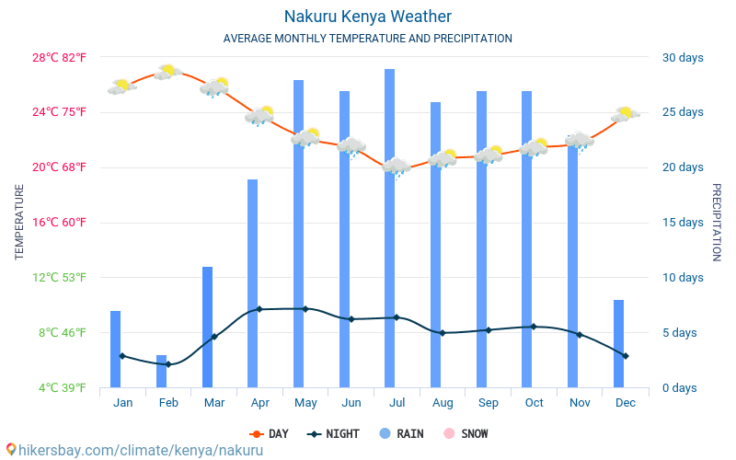The climate in Nakuru can be described as cool and warm. Temperature ranges between 16°C during the cold season and 23°C in the hot-warm season. Nakuru receives an average rainfall of between 500mm and 2600mm each year.

These charts illustrate that the precipitation is highly seasonal, concentrated throughout the winter months. The seasonal nature of Nakuru County’s rainfall has important implications in the design and operation of a hydroelectric facility. A facility can either be designed to utilize the high winter flow-rates at the expense moderate production during summer, or it can be designed to operate at lower flow-rates—and correspondingly lower power output—but for greater periods of time. A clearer understanding of the relationship between time and flow-rate begins with the construction of a precipitation expedience chart.

### 3.2.1 Precipitation Exceedance Chart

The Nakuru lies on 1871 m above sea level. The climate here is mild, and generally warm and temperate. The rain in Nakuru falls mostly in the winter, with relatively little rain in the summer. The Köppen-Geiger climate classification is Csb. The temperature here averages 17.5 °C | 63.5 °F. The rainfall here is around 895 mm | 35.2 inch per year. At an average temperature of 18.8 °C | 65.8 °F, March is the hottest month of the year. At 16.8 °C | 62.2 °F on average, July is the coldest month of the year.

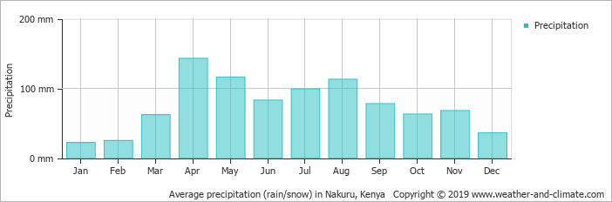The precipitation exceedance chart is used later in this study to estimate the volumetric flow-rates at the study sites and for determining optimum flow-rates for system operation. A larger version of the chart is provided in Appendix A.

## 3.3 General Topography

**Administrative classification**

 Administrative region (level 2)

0° 17' 0" South, 36° 4' 0" East

Elevation 1890 m

### 3.3.1 Drainage Basins

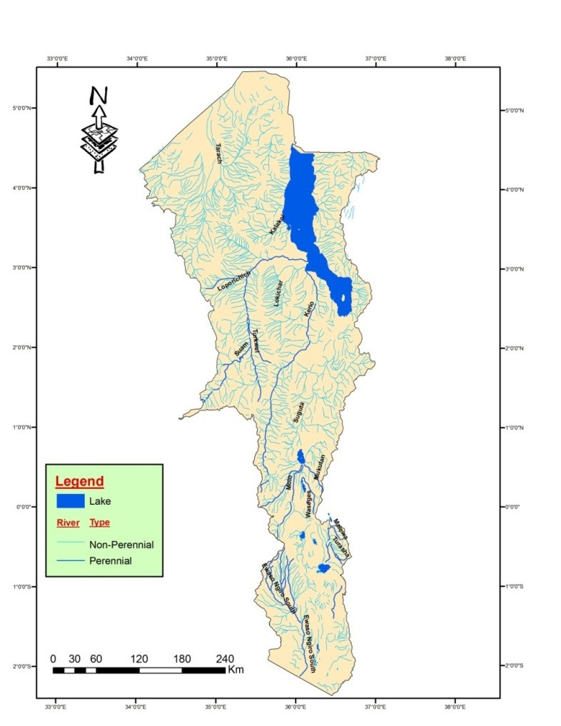

**Map of Kenya Showing R. Valley area of coverage**

The limits of the area are: the Man Escarpment to the west; the Eburru Volcano to the south; and the Kamasia Reserve to the north. The eastern limit was taken along the line of the Subukia—Bahati Forest Escarpment and its southerly extension in the Gilgil Escarpment. A part of the Njoro area has also been included. For convenience the area has been divided into six sub-sections:— (1) Nakuru. (2) Rongai. (3) Solai—North Menengai. (4) Kampi-ya-Moto—Lomolo. (5) Elementaita. (6) Njoro (North).

### 3.3.2 Runoff Percentages

Runoff is generated by rainstorms and its occurrence and quantity are dependent on the characteristics of the rainfall event, i.e. intensity, duration and distribution. There are, in addition, other important factors which influence the runoff generating process.

Rainfall intensity is defined as the ratio of the total amount of rain (rainfall depth) falling during a given period to the duration of the period It is expressed in depth units per unit time, usually as mm per hour (mm/h).

Runoff is analyzed by using mathematical models in combination with various water quality sampling methods. Measurements can be made using continuous automated water quality analysis instruments targeted on pollutants such as specific organic or inorganic chemicals, pH, turbidity etc. or targeted on secondary indicators such as dissolved oxygen. Measurements can also be made in batch form by extracting a single water sample and conducting any number of chemical or physical tests on that sample.

### 3.3.3 Site Selection Criteria

Each of the drainage basins within Nakuru County was evaluated to identify potential sites for hydropower development. The criteria used for site selection are as follows:

• Access to water

• Height of drop

• Catchment area size

• Proximity to low voltage utility lines

• Ecological impacts

• Property status

### 3.3.3 Access to Water

Obtaining water from the storm system is not as easy as fitting a turbine to the end of drainpipe. As explained in Chapter 2, water needs to be confined in a penstock over vertical drop in order to generate the pressure head required to drive a turbine. The existing storm system itself cannot be used as the penstock since it utilizes open channel flow at atmospheric pressure. Furthermore, any attempt to use the storm system for purpose for which it was not engineered could result in unintended consequences, such as flooding, erosion and property damage. For this reason, the hydroelectric plant must be able to collect water from the storm system without affecting the normal operation of the system.

Specifically,

• The hydro plant must build its pressure head in a separate pipe that runs to the turbine.

• The collection point must not allow water to backup into the storm system.

• Downstream of the turbine, water must rejoin the storm system with little or no disruption to its operation.

These constraints, combined with the fact that the majority of the storm water infrastructure is buried beneath county streets, significantly limit the number of sites that lend themselves well to hydropower development. While it is conceivable that water could be diverted at almost any point in the system and routed downhill in a parallel pipe, the cost involved in digging up streets to lay additional pipe would greatly increase project costs, unless the work could be piggybacked on other infrastructure projects, such as planned upgrades or repairs. For this reason, this study focuses on identifying areas where a penstock can be routed down a significant slope with the least amount of disruption.

### 3.3.4 Height of Drop

As explain in Chapter 2, hydropower is a product of head and flow-rate. While the fundamental relationship (equation 2.1) makes no distinction between sites with high head and low flow versus ones with the opposite characteristic, the difference can be considerable. All else being equal, sites with high head almost always result in lower system costs (Masters, 2004). Therefore, sites with the highest heads are given preference in this analysis.

### 3.3.5 Catchment Area Size

The average rainy day in Nakuru County results in 17.3 cubic inches of runoff per squarefoot16. A large catchment area is therefore needed to collect sufficient volumes to drive turbine. While no minimum size has been set as a criterion, all else being equal, preference is given to sites with large catchment areas.

### 3.3.6 Proximity to Low Voltage Utility Lines

A site may possess good head and flow characteristics, but if it is far removed from the electrical grid it may not be cost-effective to develop. Installing an overhead or underground power lines can involve considerable expense. The site must be within reasonable distance of PGE’s electrical distribution system.

### 3.3.7 Ecological Impacts

The primary mission of this study’s sponsor is to promote resource conservation and sustainable practices. Respecting that mission, this study rejects sites that would rob water from streams and riparian areas. Such an approach reflects sound environmental stewardship and is deemed necessary for project approval by primary stakeholders.

### 3.3.8 Property Status

To avoid legal complications and the uncertainties involved in property leasing agreements, only publicly owned lands are considered in this analysis.

### 3.3.9 Study Sites

Of the numerous sites considered in this study, two were selected for detailed analysis.

## 3.4 Summary

This chapter discussed the climate, topography, hydrology and storm system infrastructure of Nakuru County. Three site-selection criteria were identified to facilitate the evaluation of potential sites for hydroelectric development. Three sites were proposed for detailed analysis. Evaluations of these sites follow in subsequent reports after detailed ground a scientific study has been carried out

3.5 proposed working of microelectric power generation plant

concept

Materials

Project parameters

Project outputs

Timelines

Budget

# 4.0 Conclusions and Recommendations

Based upon the observation presented in this report, a hydroelectric project for Egerton University is technically and economically feasible at Ndarugu River.

The recommended hydro project is economically superior to continued diesel generation under all likely scenarios.

However, Government/institution grants or low-interest loans can help to reduce the community’s exposure to these factors and move forward with the project.

## 4.1 Development Plan & Schedule

The next major steps to advance a hydro project on Ndarugu River are:

1. Prepare and submit permit applications for the project.

2. Complete designs for the project.

3. Obtain all permits required for the project.

4. Secure construction funding.

5. Detailed scientific research is required to decide the viability of the project.

6. Detailed EIA report for the area should be availed.

7. Construction.

The longest potential lead times are securing the leases on community land and acquisition procedures. It is recommended that the preparation and submittal of acquisition applications occur as soon as possible to start this process. With the exception of the lease and acquisition, it is expected that all permits for the project could be issued in time for construction.

## 4.2 Budget proposal for feasibility study

N/A

## References

1. *G. J. H. McCall, B.Sc., Ph.D., A.R.C.S., D.I.C., Ministry of environment and natural resources, Mines and geological department, Technical Report No.3*
2. *NBI (2009). Sio-Siteko transboundary wetland community-based management plan. Nile Basin Initiative, Entebbe, Uganda.*
3. *MIRREIA Project Investor Manual (2020),* [*http://mirreia.energyprojects.net*](http://mirreia.energyprojects.net)
4. *KIEP Factsheet,* [*www.kiep.go.ke*](http://www.kiep.go.ke) *(Accessed November 2020)*
5. *Ramsar Convention Secretariat (2008). The Ramsar Strategic Plan 2009-2015. Gland, Switzerland. Http://www.ramsar.org/pdf/key_strat_plan_2009_e.pdf (Accessed on August 3, 2012).*
6. *Ramsar Convention Secretariat (2010). Wise use of wetlands: Concepts and approaches for the wise use of wetlands. Ramsar handbooks for the wise use of wetlands, 4th edition, Vol. 1.*
7. *Ramsar Convention Secretariat, Gland, Switzerland. http://www.ramsar.org/pdf/lib/hbk4-01.pdf (Accessed on August 3, 2012).*
8. *UNDP (1990). Safe water 2000. New York.*
9. *Wetlands International (2012). Degradation of Kenya’s wetlands. http://www.wetlands.org/Whatwedo/*
10. *Ouractions/KimanawetlandsKenya/DegradationofKenyaswetlands/tabid/2257/Default.aspx (Accessed on August 6, 2012).*
11. *WRMA (2009). Strategic Plan 2009 – 2012. Water Resource Management Authority, Nairobi, Kenya.*
12. *Johansson, J. and Svenson, J. (2002). Land degradation in the semi-arid catchment of Lake Baringo, Kenya: A minor field study of physical causes with a socioeconomic aspect. Earth Sciences, Goteborg University,*
13. *Government of Kenya. Vision 2030 Document. Government Printers, Nairobi.*
14. *Government of Kenya 2011. Scaling-Up Renewable Energy Program (SREP) Investment Plan for Kenya Draft*
15. *Eberhard A. and Gatwick K., “The Kenyan IPP Experience”, Working Paper No 49, Nov. 2005*
16. *Eberhard et al, “Africa Infrastructure Country Diagnostic, Underpowered: The State of the Power Sector in Sub-Saharan Africa”, Background Paper, May 2008*

Copy rights reserved

© 2020